CECIL ANDREWS COLLEGE

**ATAR Human Biological Science Unit 3**

**HOMEOSTASIS**

**Multiple Choice Question Booklet**

## STRUCTURE OF THIS PAPER:

|  |  |  |
| --- | --- | --- |
| Section | Number of questions available | Marks allocated |
| Multiple Choice | 10 | 10 |
| Short Answer | 4 | 40 |
| Extended Answer | 1 | 10 |

Section A: Multiple Choice *(10 Marks)*

## This section has 10 questions. Attempt all questions. Indicate your answer/choice by placing a cross over the appropriate letter on the separate Answer Sheet.

1. Overactivity of the thyroid gland causes an increased metabolic rate. Which of the following would NOT be observed in such a case?
2. Rise in body temperature
3. Nervousness
4. Excitability
5. Increase in weight
6. What is the immediate effect the removal of the pancreas would have on the composition of the urine of a human?
7. Amino acids appear in the urine
8. Glucose appears in the urine
9. The concentration of the urine decreases
10. The urine contains less urea
11. The urine of a diabetic patient contains an abnormal amount of:
12. Amino acid
13. Urea
14. Glucose
15. Mineral salts
16. The amount of water reabsorbed in the kidney tubules is controlled by the:
    1. Antidiuretic hormone
    2. Insulin
    3. Adrenalin
    4. Thyroxine
17. Which of the following pairs of hormones are antagonistic in regulating the interchange of glucose and glycogen?
    1. Glucagon and insulin
    2. Insulin and thyroxine
    3. Thyroxine and adrenalin
    4. Adrenalin and glucagon
18. Excessive production of antidiuretic hormone could result in
    1. Excessive thirst
    2. Retention of water in the body
    3. Retention of urine in the bladder
    4. Excessive urine formation
19. The receptors which cause the changes in heart rate would be **most** sensitive to which factor?
    1. Blood Carbon dioxide concentration
    2. Blood Oxygen concentration
    3. Blood osmotic concentration
    4. Blood pressure
20. When blood is lost from a mammalian body, arterial blood pressure falls. Which of the following responses would assist in restoring blood pressure?

a) Decrease in heart rate

b) Vasoconstriction

c) Decrease in lymph flow

d) Decrease in urine production

The next two questions refer to the diagram below.

The diagram shown below represents somatic cells surrounded by their fluid environment, including a blood capillary and lymphatic vessel

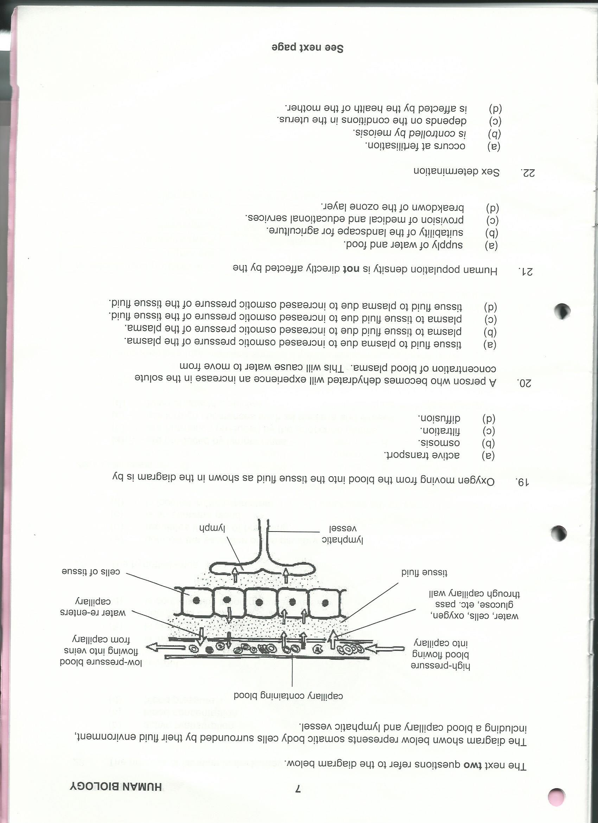

1. Oxygen moving from the blood into the tissue fluid as shown in the diagram is by
   1. active transport
   2. osmosis
   3. filtration
   4. diffusion
2. A person who becomes dehydrated will experience an increase in the solute concentration of blood plasma. This will cause water to move from
   1. tissue fluid to plasma to increase osmotic pressure of the plasma
   2. plasma to tissue fluid due to increased osmotic pressure of the plasma
   3. plasma to tissue fluid due to increased osmotic pressure of the tissue fluid
   4. tissue fluid to plasma due to due to increased osmotic pressure of the tissue fluid